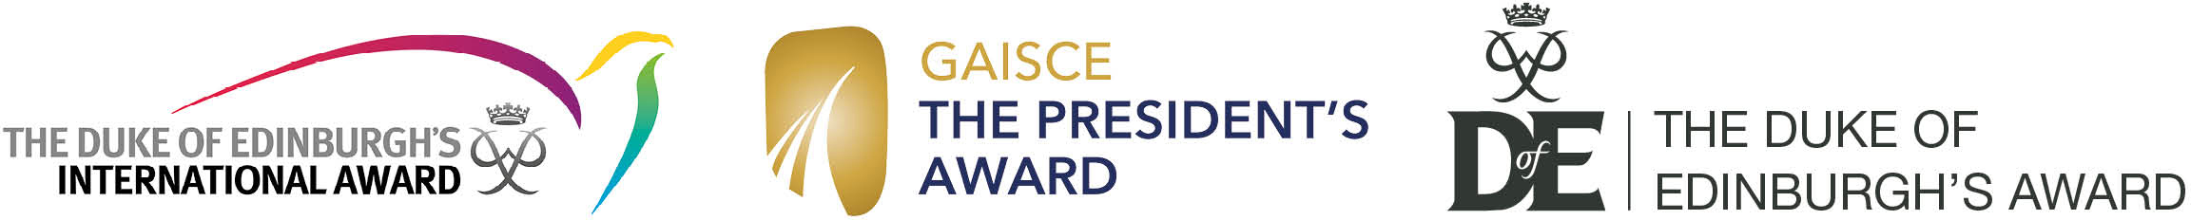

The Award is the world’s leading youth achievement Award which gives 14-24 year olds the opportunity to be the best they can be. There are three progressive levels of programmes, which when successfully completed, lead to a Bronze, Silver or Gold Award.
Gaisce - The President’s Award and The Duke of Edinburgh’s Award work in partnership through the Joint Award Initiative (JAI) to offer Award participants in Northern Ireland a choice of recognition for their achievements. They can choose a Duke of Edinburgh’s Award, a Gaisce – The President’s Award or a Duke of Edinburgh’s International Award Certificate.

This form should be completed by the DofE/JAI centre Co-ordinator or Leader.
A copy of the enrolment form for each participant must be sent along with this request form. DofE/JAI NI Office staff will input the information provided online. It is essential that participants are created online as soon as possible after they enrol for their programme. Please ensure that where possible this form, along with the copy enrolment forms, is sent within 4 weeks of the participant enrolling.
Requests for the DofE/JAI NI Regional Office input must be supported by the centre’s Licensed Organisation and then sent to the DofE/JAI NI Office.
Directly Licensed Centres should apply directly to the DofE/JAI NI Office.

Type of application: | Application for a group
Centre name: |  | Date:
Licensed Organisation
Contact number and email:
Licensed Organisation:  Support of LO Manager any additional comments: |  | Date:
DofE NI Office:  Approved/declined |  | Date:

Please remember to attach a copy of the participant enrolment form for each young person to this request form.

